This article is originally written in Italian. It mainly provides information to help identify the year, make and model of those old bandoneon.Should you have any question, please check with the original context and contact its author: http://lavozdelbandoneon.blogspot.com/p/bandoneon-4-tassonomia.html

In order to provide a series of useful elements to recognize the pattern of a bandoneon that we can find on the market, I will present here a series of identifiers. None of them is that in absolute terms but must be assessed globally with the others.
A number of factors (lack of production records with specified serial and corresponding models, the habit of factories to store components and spare parts sufficient to produce a long-term repairs that may have undergone tool - some now nearly a century old, or lively septuagenarian in the best case ...) may have altered its original appearance. Last but not least, the explosion of prices in the international market, has "invited" some traders "unscrupulous" to "add" stamps "of nobility" instruments of uncertain origin ...
And yet often the tools were made interventions, even adjusted for the easy recovery of their duties, but sometimes a little respect standards required for an accurate historical restoration.
An example would be the replacement of parts (such as the tapa of the right hand) or worn with other wrecks from bandoneon "cannibalized" because now unusable except as a source of spare parts. (This has already become a common practice for the reeds, but also for other components). But a series of concomitant elements can help in rebuilding their lives more or less "sedentary" or "adventurous" of an instrument, and therefore the correctness of its economic assessment.
Among these identifiers can include the design of the notches of the boxes, decoration and mother of pearl fillets alpaca, any stamp that we can meet inside the instrument.
The valve cover plate, equipped with trademark or distinctive pattern, can not be considered an element identifier to its interchangeability, (also considering that many musicians the eliminated to reduce the noise of the air), however, it will present a series of images. A plaque correct and the instrument is a factor of historical and aesthetic completion.

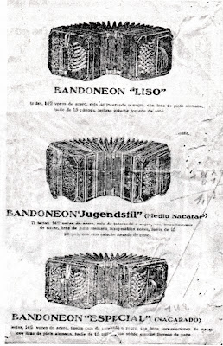
Divide the material in the three usual types of decoration (nacarado complete medionacarado and worn like the picture of the catalog of Arnold here) and by pooling the three "blocks" production: the ELA, with various models "ELA", "Germany" , "Tango", "Cardenal", "Echo", the Arnold ("AA", "Premier" and templates provided to other companies as "3B", "Field" and "America"), and keyboard instruments with Einheits 144 or produced in the postwar period, of little interest to those who want to play the tango., but unfortunately "haunt" the market, often causing incorrect purchases by enthusiastic students are beginners. premise that all the data that I will present arise from a search for " empirical "conducted tools (few, alas, in relation to the total outputs) that I could look at live data and photographs collected over several years about tools appeared for sale on the market. A first difficulty is the lack of production records with precise dates refer to the serial numbers and models. ELA often placed inside a stamp with the date of completion of the instrument and sometimes a later date with the quality control, and Alfred Arnold did not do it rarely.
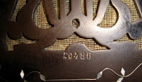
serial engraved in the wood under the lira
There are, however, for Alfred Arnold, some data-approximate-corroborated by a patient "cataloging" of serial I could gather. In this regard, remember that the only serial I am referring to are those stamped inside the crates with the prefix B (ie Basseite side of the lower-left) and the prefix D (ie Diskantseite side of the high-right side). The serial number etched into the wood under the lira notch on the right side of the "DobleA" seems to meetings only instruments exported and its progression does not match
the internal serial progression, of course if it concerns only export tools, which could also be stored for some time before the sale. Some serial and date of production by way of example Tools Alfred Arnold
Serial stamp in violet ink, prefix B and D. Eventually, though very rarely, stamp
with the date of completion of the instrument. Production includes (and mixed) all models - AA and the types Premier Luis XV, reinische, Einheits and concertinas - and those built to order - Field, America, 3B ... 1923 - n ° 15900 03.01.1928 - n ° 26673 6/27/1929 - n ° 31769 - brown 1/2 nacar "Jugendstil" first type 04.11.1930 - n ° 32699 - black worn "de estudio" (single reed) 03.02.1931 - n ° 32007 7/10/1936 - n ° 101770 - black nacarado 09.29.1936 - n ° 104735 - black worn 03.02.1937 - n ° 105700 - brown threadbare 09.22.1937 - n ° 107282 - black 3/4 nacar "Jugendstil" Second Variety 07.20.1939 - n ° 111703 - black nacarado 08.03.1939 - n ° 112232 - black nacarado April 1942 - No. 113138 1944th April - n ° the 113,945th the 1950th - n ° 115581 - 128 Einheits celluloid gray tones (with a total of 87,281 products manufactured in only 11 years from 1923 to 1934!) ELA Tools
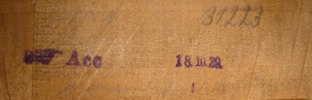
Even in this case models (ELA, Germany, CB Arnold unisonori, Cardenal, etc.) And decorations mixed.
ELA In the case of the serial is normally written by hand in pencil on soundboards and in the interior of the boxes, while it is almost always have a stamp with the date of termination of the instrument. 1928 - from 27xxx to about 29XXX 21.05.1928 - n ° 27497 mod. Cardenal 1/2 nacar marron 31.05.1928 - n ° 27 792 mod. America nacarado black 08.12.1928 - n ° 288xx mod. Luis XV nacarado brown 1929 - from 29XXX to about 32xxx 15.07.1929 - n ° 306XX mod. Germany decor "Germany" 19.08.1929 - n ° 29269 mod. Luis XV nacarado black 10.18.1929 - n ° 31223 mod. CB Arnold unisonoro ("color") nacarado marron 11/12/1929 - No. 319XX mod. Echo threadbare black 1930 - from 32xxx to 34xxx on 15.01.1930 - n ° 32438 mod. Germany black decor "Germany" 29.09.1930 - n ° 33253 mod. ELA threadbare black
FINISH AND DECORATION

Details of decoration and mother of pearl alpaca models "nacarado"
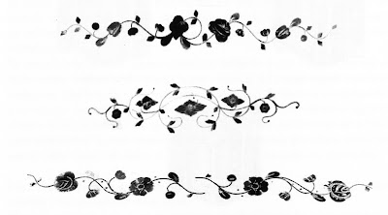

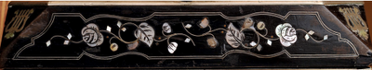

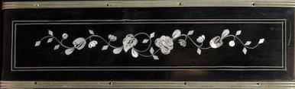

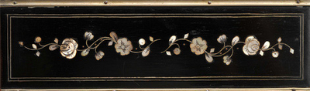

Details of alpaca and mother of pearl decoration in Art Deco style
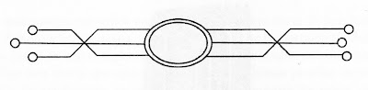

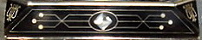

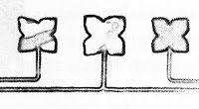

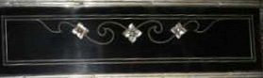

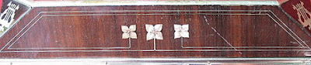

Exterior decoration - compare their respective models ELA and Arnold
ELA | AA
Worn brown
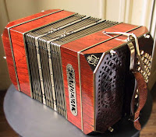 | 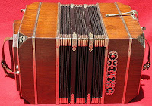
Worn black
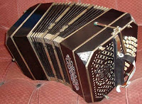 | 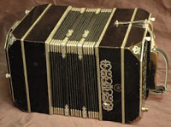
Medionacar marron "Jugendstil" first type
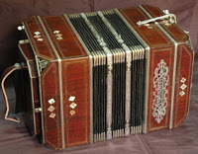 | 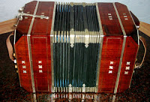
Medionacar black "Jugendstil" first type
 | 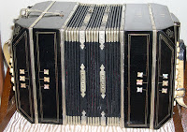
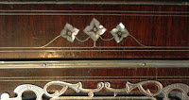 | 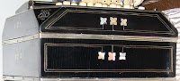
Fillets and inlay detail
Medionacar "Jugendstil" second type
(defined incorrectly "3/4 nacar" to distinguish it from the previous year)
Probable evolution of the "medionacar -" Jugendstil "first type
 | 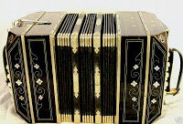
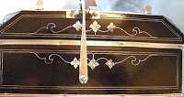 | 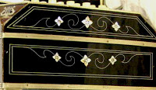
Fillets and inlay detail
This second type is only encountered in the production of the decade '30-'40
and at the same time seems to cease production of the first type.
In catalogs Arnold are both marketed under the definition model "Jugendstil".
Typical inlays "Art Deco 'of ELA mod. "Germany" medionacar
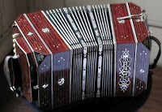 | 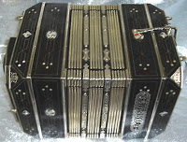
Detail of the medallion on the case of bellows | Detail of the medallion on the tapa
Nacarado complete
ELA pre 1917 (the characteristics of lire) | Premier
ELA produced the 16/06/1931 | About AA 1933
ELA "Germany" (note the characteristic wavy threads)

Special features
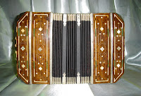 | 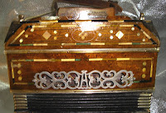
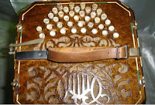
A rare example of the 1928-29 AA (serial 28215)
veneered in burr with an inlay "Art Deco" reminiscent of the models "Germany"
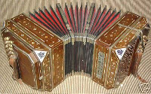 | 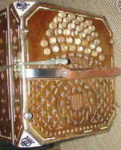
And ... the same decoration, but produced around 1930 by ELA, in a model "Cardenal"

The CARVING OF CASES
A first element for recognizing the "family" to which belongs a bandoneon, and at the same time the most recognizable element, is the carving of "tapas" (the lids of the boxes), and in particular that of the right side. Each manufacturer developed one or more "design" typical of its production, which can also help us to recognize the original "authorship" beyond the various names for commercial purposes or in the case of productions of "subcontracting" (as we have already got to see the notes on the export of the previous chapter).
E.LA. and models derived
As can be seen from the photographs, the carving typical of the ELA with the characteristic rose window of the lyre in his right hand, remains practically constant in all models, from the beginning of '900, (even those made on behalf of third parties as the model "Germany"), confining most of the time to replace the valve cover plate. Another characteristic feature of the ELA, medionacar in the model are the desired rolling fillets alpaca, with respect to the geometric rigor of Arnold. The only difference is that we can meet the presence or absence of the row of circular holes on the outer edge of the notch of the right speaker.
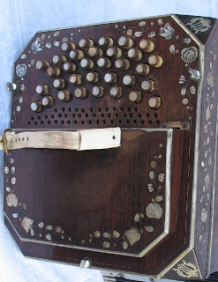 | 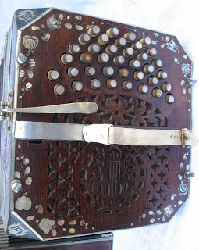
ELA circa 1915
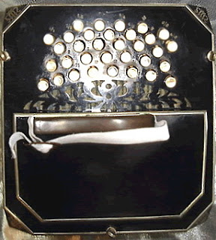
"Germany" (ELA)
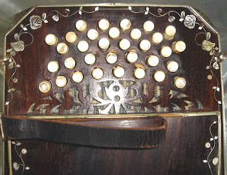 | 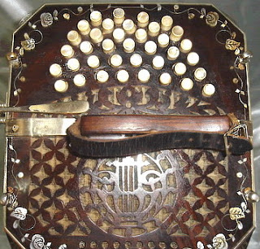
"America" ​​(ELA)
ELA also provided, such as AA, bandoneon to "America House" when it was replaced the plaque
"ELA" with that "America." Often encountered between these models with a single reed instead of
two for each note. They are the so-called study models, cheaper, made ​​to allow
un'approccio less expensive to students. Obviously the sound is weaker ....
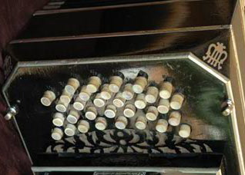 | 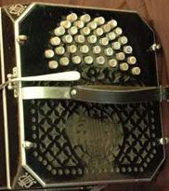
"Echo" (ELA)
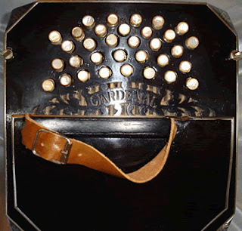 | 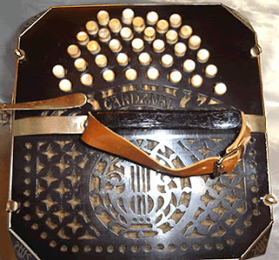
"Cardenal" (ELA)
 | 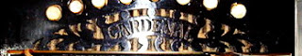
Unlike models "ELA", "Germany", "Tango" and "Echo" models "Cardenal" meets a modification of the notch near the small buttons on both "tapas" with the model name inserted on the track carving usual.
Valve cover plates production ELA
As can be seen, we encounter two types of plaque. That spiral processed (note how the plaque "Germany" basically reproduces all the graphical features of the plaque "ELA"), and the simplest form of which is limited to change the name of the model. For an analysis purely aesthetic, the second seems more suited to the taste geometry of the '30s, while the first is still suffering from the royalties charts the late nineteenth century / early twentieth century.
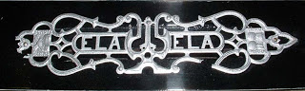 | 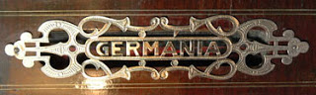
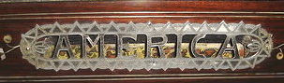 | 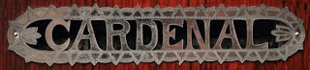
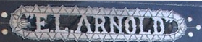 | 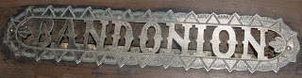
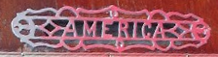
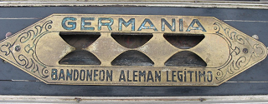
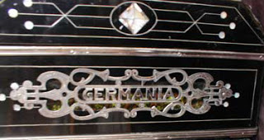 | 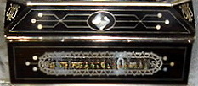
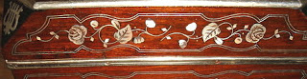 | 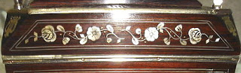
Typical threads undulating cornices decoration in ELA "Germany", in comparison with the
threads of a geometric ELA both "model nacar complete."

ALFRED ARNOLD
In his production meet always and only these two types of carving, the first to the second half of the '20s, the second to follow until the end of the pre-war production. (And then change the last productions later) During the period 1927-1930 meet both (Arnold obviously stored away spare parts for production needs long-term) It is said that the second type was born from the need to clearly distinguish their instruments from those of the ELA ( hence the 2 A carved before it was present only in the small notch that will remain unchanged throughout the production). In the Premier and those provided to other exporters always comes in the first type, regardless of the year of production. The changes are small sull'intaglio in which A is replaced with the name of the model (Premier) or with the initials of the exporter (MH Meiner Herold for "3B") or by a sort of turbot (the latter I attributed seen several times by sellers "inaccurate" in a hypothetical production of Zimmermann, which as we have seen, had already left the production in 1864 ....). If you look at good design, we note that the carving is actually the same as Arnold.
Type 1 (1911 -?) | 2nd type (? -1939)
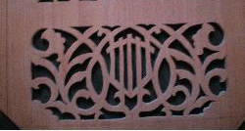 | 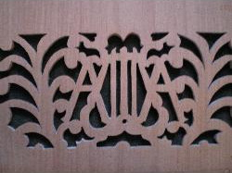

AA first type
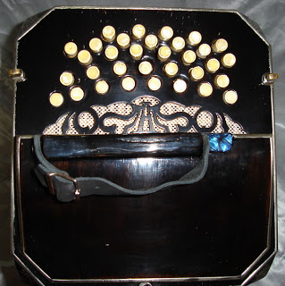 | 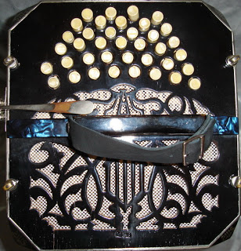
AA second type
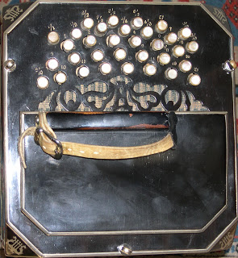 | 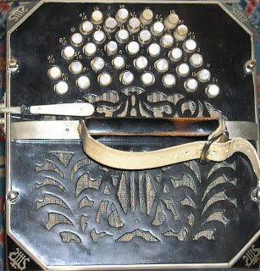
Third type - "Premier"
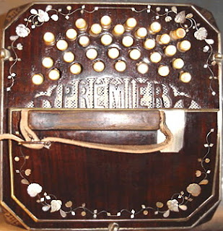 | 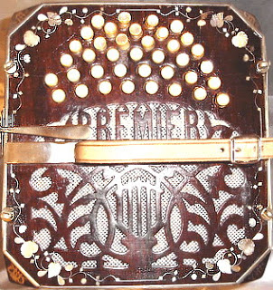
(Note the change of the notch near the buttons with the model name)
A third type - usually in models "unofficial" as the "Field" and "America"
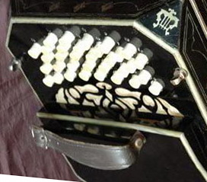 | 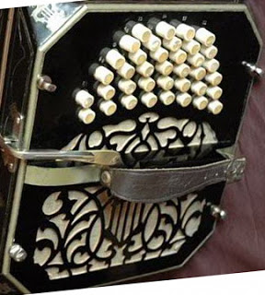
(Note the change of A in a sort of small diamond in the notch)
Fourth type "Alfa" postwar 142 tones (about 1945-50)
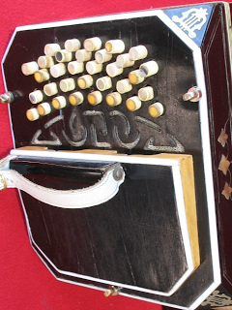 | 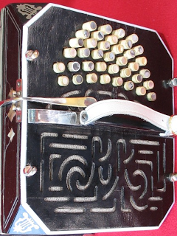
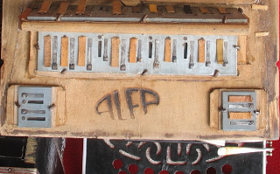
note also change the type of lire.

Economic model to single reed for students.
The lire suggest its origin AA. The tunnel on the right speaker matches that of the first bandoneon concertina economic and nineteenth centuries. Products with small size suitable for children who began the study
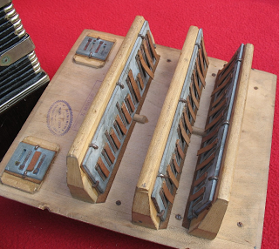 | 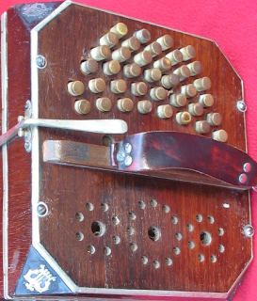

"3B" Meiner Herold (manufacture AA)
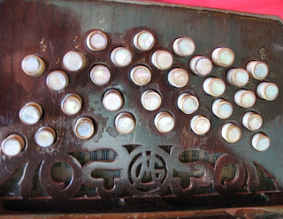 | 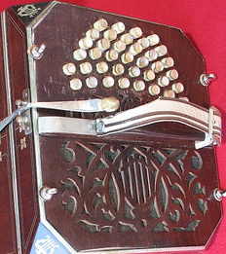
Instead of "A" notch small, the MH logo

Valve cover plates production Alfred Arnold
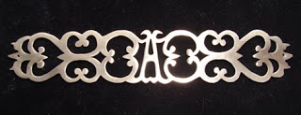 | 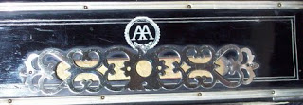
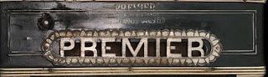 | 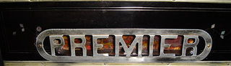
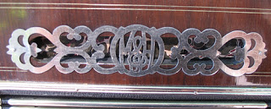
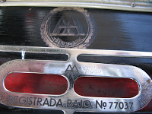 | 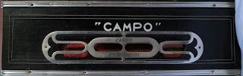

Labels and internal sounds
Often the soundboards are the manufacturer stamps and stamps lab tuning, which help to track the "past" of the instrument.

ELA
Label ELA .
usually on the inside of the boxes

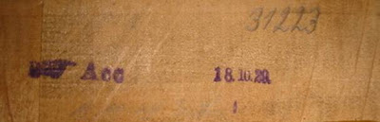
Stamps usually present in ELA on the soundboards: on the left the stamp of the "control
quality "at the end of the manufacturing process - right on the date of completion and pencil
serial number of the bandoneon - which is also found on other components such as combs reeds -
marked by the laborer tuner not mix components from different instruments in the works ..

Chronological evolution of this stamp AA (often) on soniere
about 1920 | about 1920 | end of decade 1920
1930/1939 | 1930/1939 | Branding of AA  postwar
Stamps on soniere
(Left a model of the early 20s - right model of the '30s)

Brands
Brand painted in silver "Premier"  (above the valve) | Brand painted in silver of the "AA"  (above the valve)
Label AA and Premier (this sometimes means the end of the decade of 1930)

Stamps of tuners
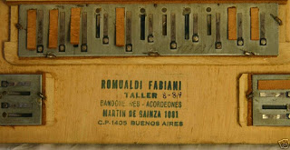
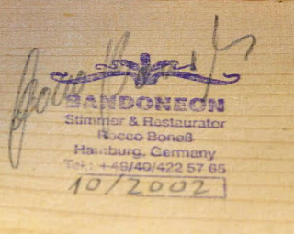 | 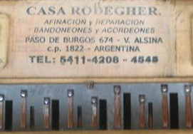
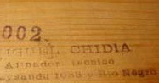 | 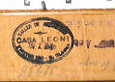
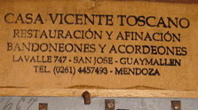 | 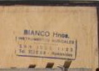
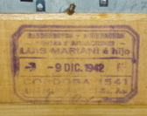 | 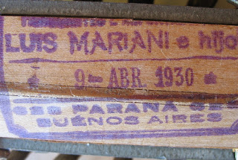
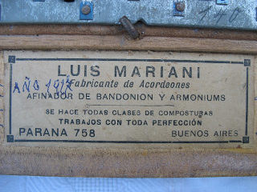

The lire at the corners of the boxes
Another element to help identify the bandoneon.
unfortunately subject to change, being one of the most subject to wear and accidents
The lira typical of ELA | 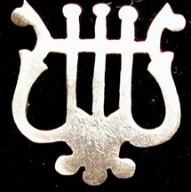
other models ELA
ELA No. 139xx  (prior to 1917) | ELA No. 196xx and many models  LuisXV (20s) | ELA "Germany"
The typical pound of AA  with the protruding tips. | 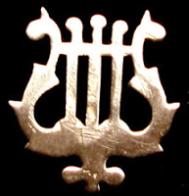
other models AA
Lira used by Arnold at the beginning of production and later models "America" ​​and "Field" | "3B" production Arnold | AA postwar

Production post-war
Alfred Arnold 142 tones
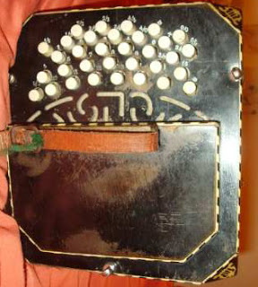 | 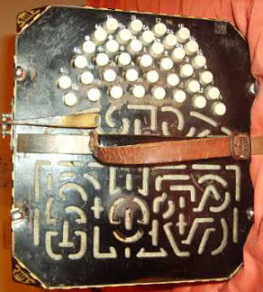
 | 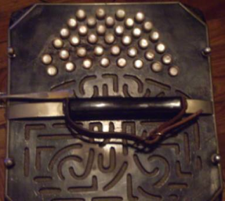

Arno Arnold 142 tones
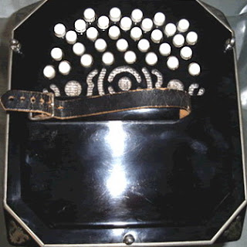 | 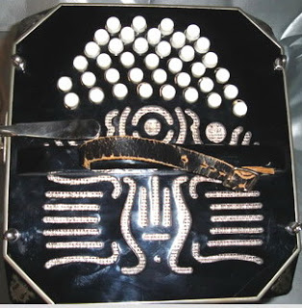
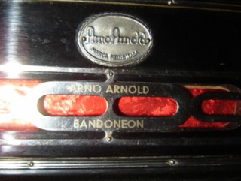 | 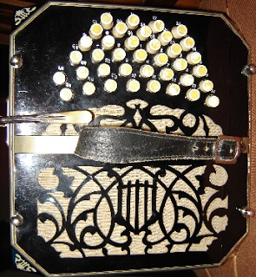
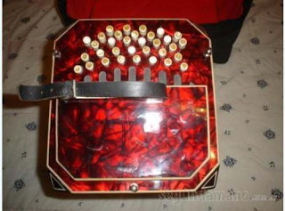 | 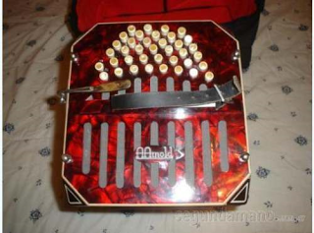

Elettra (Luis Mariani) 142 tones
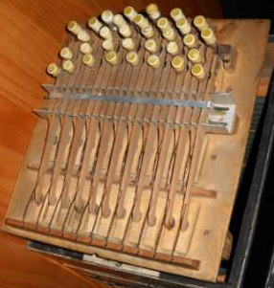 | 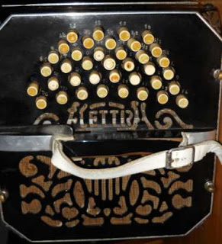
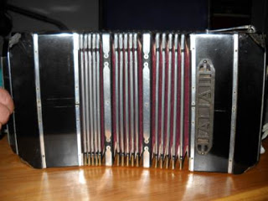

SPECIAL MODELS
"LUIS XV"
The name (unofficial but now in common use) comes from the rounded shape of the speakers. These models are the "luxury" in the late '800 and early '900, often with full keyboard 152 tones and always riccammente decorated. Montano (almost) always combs made of aluminum. Weight, size and especially the stamp of aluminum, making them attractive pretty much just for the collector or antique dealer. Were produced by both the ELA that AA | 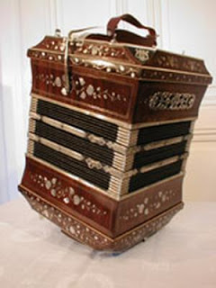
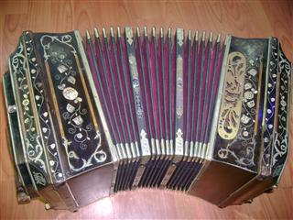 | 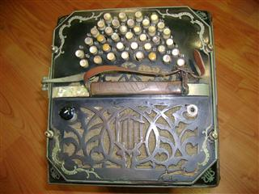

CURIOSITY '
"Bandoneon Trumpet"
Bandoneón fabricado by ELA in 1915, 132 tones registers and "amplification" in the handset.  remember the "violin corneta" (Stroh violin, violinophone) played by Julio De Caro ... | 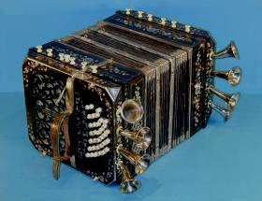
Tanzbar (bandoneon perforated roller)
Similar to the player piano, work through a roll of punched paper fed by spring. The executor must only supply air pressure to the bellows. | 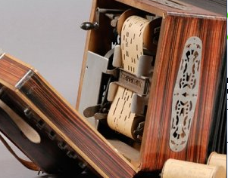
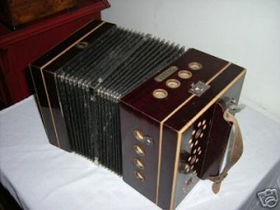 | 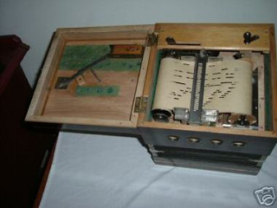
Piano-Alfred Arnold bandoneon - unisonoro
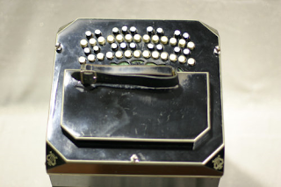 | 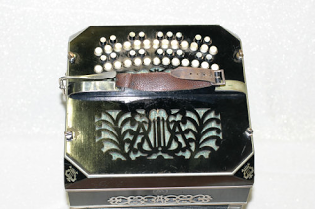
Bandoneon unisonoro with buttons blacks and whites to distinguish the natural notes from the alterations.
Produced in very few copies around 1935. 44/44 ° in 2 tones of aluminum plates.
AA 236 tones - bisonoro
extension 7 octaves - aluminum plates - n ° 103254-1937
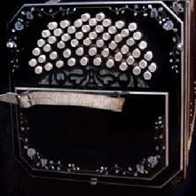 | 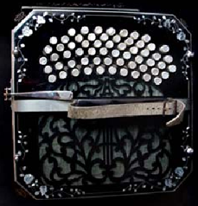
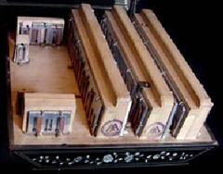 | 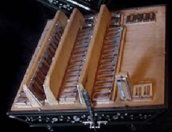
Built on request and project Enrique Di Cicco "Minotto" (also called "Mano good.")
The original design included 122 buttons, but were reduced to 118 (61/57) to insurmountable
difficulties of construction.
Other types of valve cover
Model 88-tone late '800 | Bandoneon without "ochavas" (Agoli rounded) about 1890-1910
Luis XV production ELA | ELA likely early 900
Various models of valve cover "L. Mariani "

